(software engineering and administration)
1)Study the traffic signal and the importance of rules and process
Traffic rules and signs are designed to ensure the safety of drivers, pedestrians, and other road users. They are designed to regulate traffic flow, reduce the risk of accidents, and prevent chaos on the roads. Unfortunately, many people disregard these rules, leading to unnecessary accidents, injuries, and fatalities.
Traffic signal rules universally require drivers to Red (Stop), Yellow (Caution/Prepare to stop), and Green (Go), with flashing red acting as a stop sign and flashing yellow meaning proceed with caution. Always stop behind the line at a red light, be prepared to stop at yellow (don't speed up), and proceed with care on green, yielding to pedestrians and other vehicles in the intersection, using turn signals.
Standard Signal Meanings
- Red: Stop completely behind the stop line or crosswalk. Wait until the light turns green.
- Yellow (Amber): Caution. Prepare to stop, or if already in the intersection, proceed carefully. Don't try to beat a red light by speeding up.
- Green: Go, but proceed carefully and be aware of pedestrians and other traffic.
Special Signals & Situations
- Flashing Red:
Treat as a stop sign. Stop completely, yield to all traffic, then proceed when safe.
- Flashing Yellow:
Slow down and proceed with caution, as the intersection might be unsafe.
- Green Arrow:
Proceed in the direction of the arrow, yielding to pedestrians and vehicles already in the intersection.
- Pedestrian Signals:
Look for walking figures or symbols indicating it's safe for pedestrians to cross.
2) Visit various consulting company web portals and collect case studies.
Case studies simulate aspects of consulting assignments and may even be based on a recent project led by the interviewer. Each case allows the recruiter to assess your capability and performance and you will need to perform well on a number of case studies to secure an offer of employment.
While various classifications exist, four common forms of case studies focus on their purpose: Exploratory (preliminary research), Descriptive (detailed portrayal), Explanatory (explaining cause-and-effect), and Intrinsic/Instrumental (studying a unique case for its own sake or to understand a broader issue). Another set of four, often used in education, includes Illustrative, Exploratory, Cumulative, and Critical Incident.
- Exploratory Case Study:
Used when little is known about a topic, acting as a pilot study to identify key issues or develop hypotheses for further research.
- Descriptive Case Study:
Provides a rich, detailed account of a phenomenon within its real-life context, answering "what, where, and when" questions.
- Explanatory Case Study:
Investigates causal links, explaining how and why events occurred, often comparing data to understand cause-and-effect relationships.
- Intrinsic Case Study:
Focuses on understanding a specific, unique case (person, event, place) because of inherent interest in it, not for general theory.
- Instrumental Case Study:
Uses a particular case to gain insight into a broader issue or phenomenon, where the case serves as a tool for understanding something else.
- Collective (or Multiple) Case Study:
Studies several cases to explore similarities and differences, often to generalize findings or replicate results.
While components can vary, a strong case study generally includes an Introduction/Background, a detailed Case Description, the Methodology used, the Findings/Analysis, and a Discussion/Conclusion, often guided by specific research Questions, theoretical frameworks, and criteria for interpreting results, especially in academic settings.
3) Document the roles and responsibilities of different agile ceremonies
The Agile software development lifecycle (SDLC) was developed with a clear goal: rapid delivery of software builds through an incremental and iterative process designed to adapt and improve software quality from an end-user perspective. The goal is readily adopted by IT departments and shops, though the process framework is not always adequately adopted.
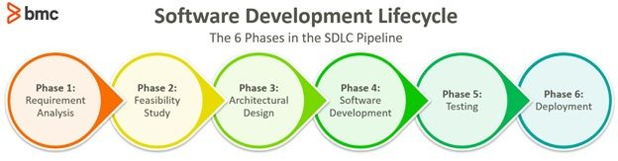
Organizations adopting an Agile approach may find themselves resorting to traditional/waterfall SDLC practices due to inappropriate distribution of Agile roles and responsibilities. So, let’s take a look at the roles that support Agile software development.
- Product Owner
- Team lead/Scrum master
- Agile developers
- Agile project managers
- Agile integrators
- Additional roles for larger scrum projects
- Agile ceremonies
- Agile roles and responsibilities matrix
Roles in an Agile team
This article explores the roles and responsibilities within the Scrum framework for Agile implementation. Some key differences in Agile team building exercise include:
- The development of holistic teams with cross-functional expertise
- Domain specialists with a broad knowledge and view of the business aspects associated with their work areas
- Stable team structures that can iterate and improve the SDLC workflows on a continuous basis.
Agile teams are often comprised of the following key roles and responsibilities:
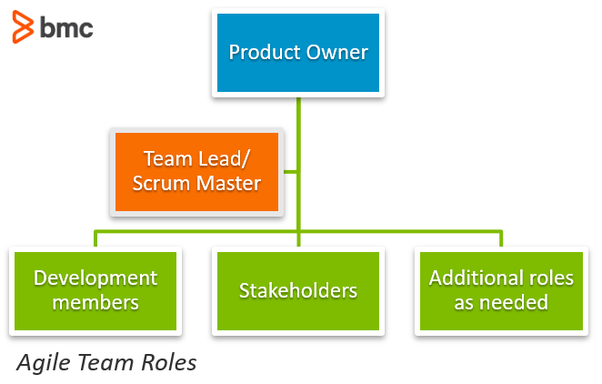
Let’s take a look at each.
Product owner
The product owner represents the stakeholders of the project. The role is primarily responsible for setting the direction for product development or project progress.
The Product Owner understands the requirements of the project from a stakeholder perspective and has the necessary soft skills to communicate the requirements to the product development team. The Product Owner also understand the long-term business vision and aligns the project with the needs and expectations of all stakeholders. End-user feedback is taken into account to determine appropriate next-best action plans for the development throughout the project cycle.
The key responsibilities of a Product Owner include:
- Scrum backlog management
- Release management
- Stakeholder management
The Product Owner is knowledgeable of the backlog items added to the list as well as items selected for work. The Product Owner changes and sets the priority of backlog item list based on stakeholder feedback and project circumstances. The role also manages the release cycle planning to ensure that the development team can deliver updated project iterations on a continuous basis.
4) Identify cost of risk; Identify commonly used risk management tools.
The Cost of Risk (COR) involves direct/indirect losses, risk control, transfer (insurance), and administration, while common risk management tools include Risk Registers, SWOT Analysis, Risk Matrices, Brainstorming, Root Cause Analysis, and software like ServiceNow GRC or RSA Archer, all helping to identify, assess, and treat threats to achieve objectives.
Cost of Risk (COR) Components
The Total Cost of Risk (TCOR) typically includes:
- **Direct Costs:
Actual losses (insured or uninsured) from events like accidents, property damage, or financial losses.
- **Indirect Costs:
Hidden costs from events, such as lost productivity, damaged reputation, or increased training, often far exceeding direct costs.
- **Risk Management Program Costs:
Expenses for administration, risk control measures (safety training), risk transfer (insurance premiums, deductibles), and loss adjustment expenses.
Common Risk Management Tools & Techniques
These tools help in identifying, analyzing, and managing risks:
Identification & Analysis Techniques
- Risk Register: A central document listing identified risks, their causes, impact, likelihood, and response plans.
- SWOT Analysis: Assesses internal Strengths, Weaknesses, and external Opportunities, Threats.
- Risk Matrix/Heatmap: Rates risks by likelihood and impact (e.g., Low, Medium, High) to prioritize them.
- Brainstorming/Interviews: Gathering diverse perspectives from stakeholders and experts.
- Root Cause Analysis: Systematically finding the primary cause of a problem.
- Documentation Review: Analyzing existing project plans, reports, and files for potential risks.
- Monte Carlo Analysis: A simulation technique to model probability and impact of risks.
Software & Methodologies
- GRC Platforms: Tools like ServiceNow GRC or RSA Archer manage governance, compliance, and risk.
- Incident Reporting Systems: Track and analyze incidents to prevent recurrence.
- Bowtie Analysis/HAZOP/FMEA: Detailed methods for analyzing failure scenarios and their effects.
5) Identify a problem and explain how design thinking can be applied to solve it. Design a shopping cart to achieve ease of use, applying design thinking
The design thinking process is a problem-solving design methodology that helps you tackle complex problems by framing the issue in a human-centric way. The design thinking process works especially well for problems that are not clearly defined or have a more ambiguous goal.
The 5 Stages in the Design Thinking Process
- Stage 1: Empathize—Research Your Users' Needs.
- Stage 2: Define—State Your Users' Needs and Problems.
- Stage 3: Ideate—Challenge Assumptions and Create Ideas.
- Stage 4: Prototype—Start to Create Solutions.
- Stage 5: Test—Try Your Solutions Out.
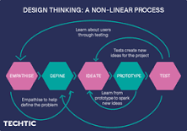
For example, an ideal problem statement would be as follows: A new parent needs to find quick and easy ways to prepare fresh fruits and vegetables because they want to give their child nutritious food for proper growth. Simply put: Our user needs nutritious food for proper growth.
6) Prepare RPM requirement traceability matrix for shopping cart List the criteria to select the requirement management tools. Identify different requirement management tools and list
their features. Identify frequently used UML diagrams and also identify tools used to draw them.
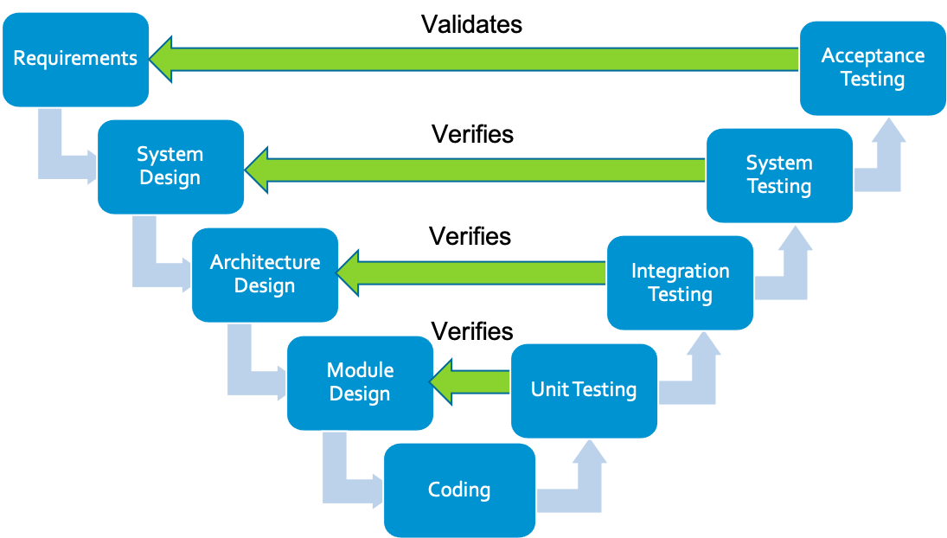
teps to create a requirements traceability matrix
- Identify requirements: Start by gathering all functional and non-functional requirements from stakeholders, specifications, or user stories. ...
- Assign unique IDs: Give each requirement a unique identifier (e.g., RQ-001) for easy tracking and reference.
Requirements Traceability Matrix (RTM) tools are software features that link requirements to their associated work items, test cases, and other deliverables. They ensure that project deliverables meet the initial requirements identified by stakeholders.
The traceability matrix enables ALM users to determine the extent of relationships between requirements and other requirements. It is also used to determine the extent of relationships between requirements and tests.
A Requirements Traceability Matrix (RTM) is a document or tool used in project management and systems engineering to ensure that all requirements defined for a system or project are traced throughout its lifecycle.
Definitions: A matrix that records the relationship between two or more products of the development process (e.g., a matrix that records the relationship between the requirements and the design of a given software component). Sources: NIST SP 800-160v1r1 from ISO/IEC/IEEE 24765:2017.
Create and export traceability reports
- Navigate to the Traceability Matrix page by clicking Traceability Matrix in the panel on the left:
- Click Report Type, and then select Forward Traceability:
- Use the primary and secondary filters to narrow your traceability matrix to include exactly what you want:
7)Explore agile estimation techniques and prepare a report.
Agile estimation estimates your effort to complete a prioritized task in the product backlog. We measure it for the time it would take to complete that task. As a result, you can plan sprints more accurately.
Trivia: A sprint is a time-boxed interval that defines the time allocated to complete a task.
Note: Even if a business accurately estimates the effort required to complete a user story in Agile, it’s not the final data. Do not strive to achieve perfect accuracy because requirements can change anytime. There are also agile anti-patterns and other emerging realities that change the development course.
Agile teams also make estimations concerning story points. A story point is used in Agile Software Development projects to estimate the difficulty of implementing a given user story. We measure it in relative units assigned to different user stories that require estimation.
A story point is a number that helps estimate the difficulty of building a user story successfully. This difficulty could be related to the complexities, risks, and efforts involved.
Agile project estimation also helps to build strong coordination. If project X depends on project Y, agile project estimation provides an overview of the wait time.
Why Run Agile Estimations?
Agile estimates are essential for
- Making teams accountable for deliverables,
- Inducing discipline across the Agile team,
- Predicting the approximate time, it will take to finish a project,
- Enabling better sprint management,
- Improving team productivity.
Why do Teams Estimate in Agile?
Overestimating and underestimating are both typical for Agile software development companies. It leads to varying development and launches times. Considering Agile estimation in the initial stages can assist in accurate user story estimations. It helps the team stick to the deliverables, and you don’t deflect.
Some of the to-the-point benefits of Agile Estimation techniques include:
8) Study boiler plate and present necessary characteristics of boiler plate for a large and small project
What Is a Boilerplate Project? A boilerplate project is a standard template that can be easily adapted to create new projects. The basic structure is adaptable. For example, an eBay seller may create a boilerplate for a store with a basic design that is ready to be filled in with new text for each product.
Boilerplate is a colloquial term used to describe stock language in a legal document that appears in all instruments of that type; general, standardized language in a legal instrument.
Boilerplate code is computer language text that you can reuse with little or no alteration in several different contexts. The term originates from document management, where you reuse document templates or boilerplate with minimal changes for different situations.
Boilerplate Code Automation refers to the process of using tools, scripts, or frameworks to generate repetitive code structures automatically, reducing the need for manual writing. It helps developers streamline tasks like setting up configurations, defining API routes, or initializing project structures.
9) Identify different DevOps Tools and list their features Study and report OWASP coding guidelines Learn and report Twelve Factor App Methodology Identify different version control and configuration management tools and report their market share.
- Jira. Flexible project management.
- Compass. Software catalog for teams.
- Pipelines. Scalable CI/CD automation.
- Bitbucket. Source code and CI/CD.
- DX. Measure productivity and AI impact.
- Rovo Dev. Agentic AI for developers.
Most DevOps tools focus on communication and collaboration, CI/deployment automation, test automation, version control, container management, monitoring, configuration management, and artifact management to help organizations create better software faster.
DevOps tools and practices include version control, Agile, CI/CD, and shift-left testing to accelerate delivery and improve quality. DevOps covers a wide range of practices across the application lifecycle. Teams often start with one or more of these practices in their journey to DevOps success.
The 7 phases of the DevOps lifecycle are a continuous loop: Plan, Code, Build, Test, Release, Deploy, and Monitor, often summarized as the "7 Cs": Continuous Development, Integration, Testing, Deployment/Delivery, Monitoring, Feedback, and Operations, all working together for faster, more reliable software delivery through automation and collaboration.
The 7 core principles of DevOps focus on bridging Dev and Ops through collaboration, automation, and continuous improvement, emphasizing customer focus, shared responsibility, systems thinking, and learning from failures to deliver software faster and more reliably, often summarized
10) Compare and contrast containerization and virtualization and identify importance of these in software development Identify container providers
Virtualization enables you to run multiple operating systems on the hardware of a single physical server, while containerization enables you to deploy multiple applications using the same operating system on a single virtual machine or server
Containerization is a software deployment process that bundles an application's code with all the files and libraries it needs to run on any infrastructure. Traditionally, to run any application on your computer, you had to install the version that matched your machine's operating system.
You can go beyond virtual machines to create a collection of virtual resources in your virtual environment.
- Server virtualization. ...
- Storage virtualization. ...
- Network virtualization. ...
- Data virtualization. ...
- Application virtualization. ...
- Desktop virtualization.
Some popular CaaS examples are AWS EKS, Google GKE, or Azure Kubernetes Service. If developers want to package applications into containers and deploy them on the cloud, then CaaS is a solution they should look at.
Type 2 hypervisors are most often used in desktop and development environments, where workloads are not as resource-intensive or critical to operations. They're also preferred in cases where users want to simultaneously use two or more operating systems but only have access to one machine. 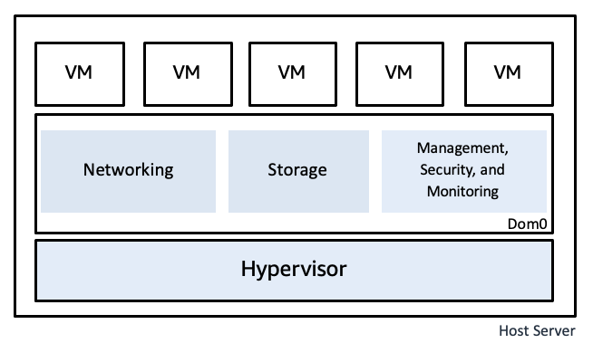

11) Study and prepare report on testing tools. Compare manual and automation testing
Manual testing is easy to learn and do, but it is highly likely to create inconsistent test results, and sometimes it takes a lot of time and effort. On the other hand, automation testing requires a lot of technical expertise to create and maintain scripts, but it checks bugs much faster with higher consistency.
Manual processes involve human effort and rely on personal skills, while automated processes use technology and machines to complete tasks more efficiently.
Automation testing works very well for many testing types. A few real-world examples: Performance testing: A performance testing tool will automatically apply different loads to the application and measure its performance. Security testing: A security testing tool will check the software for known vulnerabilities.
Modern vehicles come in two different transmission types – automatic or manual. In a manual transmission, the driver is responsible for shifting the gears, while in a vehicle with an automatic transmission, the car does the shifting for you.
The 7 Principles of Software Testing provide foundational guidelines for effective testing, emphasizing that testing reveals defects, not absence of errors, exhaustive testing is impossible, early testing saves money, defects cluster, the Pesticide Paradox means tests become ineffective, context matters, and being error-free isn't the goal if the system isn't usable. These principles, widely adopted from ISTQB, guide testers to focus on risk, efficiency, and delivering value, not just finding bugs.
12) Study and prepare report on widely used software metrics
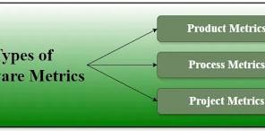
Metric | Description
Defect Density | Measures defects relative to module size.
Defect Removal Efficiency | Evaluate defect resolution efficiency.
Defect Leakage | Tracks defects missed in testing but found later.
Rework Effort Ratio | Measures effort spent on defect rework.
Utilizing accurate software metrics is crucial to the software development process as they help plan and enhance the quality of the overall software development process. This helps to reduce errors and delays and provides accurate and timely data on performance and productivity.
In software engineering and development, a software metric is a standard of measure of a degree to which a software system or process possesses some property.
Metrics not only provide a means to monitor progress but also enable organizations to set targets and measure their success against those targets. By establishing clear benchmarks, companies can evaluate their performance and identify areas that require improvement.
What are the 4 levels of software testing?
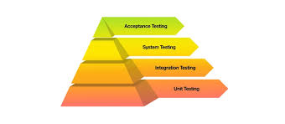
During the development process, software products undergo four levels of testing: Unit Testing, Integration Testing, System Testing, and Acceptance Testing.
13) Identify different quality tools and report their features and usage
Quality control is an essential component in the production process that ensures efficiency and functionality. Using quality tools, companies identify production problems and quality control professionals implement solutions. You can benefit from learning about various management tools for quality control to ensure that the final product fulfils the quality requirements and conforms to industry standards. In this article, we discuss the basic tools for quality control along with their primary features and review some additional tips to help choose one to meet your needs.
10 Quality Tools to Use
Before reviewing some quality tools, it is imperative to understand their definition and importance. There are many complex processes during manufacturing. Some of these processes may malfunction and result in significant delays and overhead costs. Professionals have also developed newer techniques on top of basic tools. The ten tools for quality control are:
1. Cause and Effect Diagram
Cause and effect diagrams, also known as fishbone diagrams, give a visual representation of the elements contributing to a certain outcome. You can use it to examine the relationship between variables in a process, which can help you identify which variables in a production process can lead to quality problems. This diagram typically includes six types of causes for variations in quality, which are machine, material, method, measurement, environment and people. Some key concepts include:
- Cause-effect diagrams do not identify a root cause but show graphical representations of the many factors that may explain an observed result.
- Interrelationships between the different factors are clearly demonstrated.
Related: What Is Quality Control? A Complete Guide
2. Check Sheet
Check sheets are standard, structured forms for collecting and analyzing data. They indicate potential problems a process might encounter. Employees add tally marks next to the associated field on the sheet for each problem that occurs. These marks provide employees with a way to keep track of trends. Related: Tooling Engineer Resume Example: With Tips
3. Control Chart
Control charts are graphs that illustrate how a process develops. In the control chart, you can see lines that define the upper and lower control limits, along with the mean. A data point that is outside the control limits shows that there could be a problem that needs further investigation. detecting and correcting problems in ongoing processes
- predicting the outcome of a process
- determining the stability of a process
- analyzing patterns of process variation because of special causes, such as rare events or common causes
4. Histogram
The frequency distribution describes how frequently a particular value appears in a set of data. The most common graph used to show frequency distributions is a histogram. assessing whether the process can satisfy the customer's needs
analyzing the distribution to identify the number of quality control issues
5. Pareto Chart
According to the Pareto principle, roughly 80% of consequences result from 20% of causes. Pareto charts are used to determine how frequent defects occur, along with their cumulative effect.
6. Scatter Diagram
A scatter diagram's primary objective is to show the relationship between the two variables. Using a scatter diagram, one can confirm or disprove a cause-and-effect relationship between two variables. Here are some possible correlations:
- Positive: Increasing one variable causes the other to increase.
- Negative: A decrease in one variable causes a decrease in another.
- No correlation: Increasing one variable does not affect the other.
Scatter diagrams plot numeric data pairs on axes, with each axis corresponding to a variable, to look for a relationship between them.
7. Stratification
Merging data from various sources makes it hard to interpret and derive meaningful conclusions. Stratification is the process of sorting people, data and objects into groups or layers. working with a large amount of heterogeneous data
- dividing the data based on common factors and tendencies
- identifying the source of variation amongst various categories of data
- observing the relationship between subgroups of data
8. Affinity Diagram
Affinity diagrams are pre-defined categories that organize data gathered from brainstorming sessions, research and meetings into meaningful categories. You can refer to them as affinity groups or affinity sets. involving people from different fields in finding creative solutions to complex problems
- managing large quantities of complex data and organizing them in a logical and understandable manner
- encouraging the participation of everyone involved, which leads to uncovering new patterns of thinking and unique solutions
9. SIPOC Diagram
Suppliers Inputs, Process, Outputs, Customers (SIPOC) diagrams help document business processes by providing information about its processes, suppliers, inputs, outputs and customers. It provides an overview of the participants involved in a data exchange process and aids in understanding customer service processes.
10. Failure Mode and Effects Analysis
Failure mode and effects analysis (FMEA) is a technique for identifying possible failures in a procedure and categorizing them according to severity, frequency and detection. Severity refers to the impact of the failure, frequency refers to how often the failure occurs and detection refers to how difficult or easy it may be to identify errors in a process. Here are some instances where you can use FMEA:

